1.Setting up the Python environment and libraries-Juypter Notebook

AIM:
•To Create a new notebook for Python
•To Write and execute Python code
• To Create new cells for code and Markdown
• To Demonstrate the application of Jupyter Widgets, Jupyter AI

PROGRAM:
%pip install ipywidgets google-generativeai google-colab
import ipywidgets as widgets
from IPython.display import display

slider = widgets.IntSlider(min=0, max=100, step=1, description='Value:')
display(slider)

OUTPUT:


RESULT:
Thus the program was written and executed successfully.

2.EDA-Data Import and Export

AIM:
• Importing data from CSV, Excel, SQL databases, and web scraping
• Handling different data formats
• Export a DataFrame to an Excel file.

PROGRAM:
import pandas as pd

# For CSV
df_csv = pd.read_csv('/content/Iris.csv')
print(df_csv.head())

# For Excel
df_excel = pd.read_excel('/content/exported_data.xlsx')
print(df_excel.head())

url = '/content/Iris.csv' # Replace with actual URL
df = pd.read_csv(url)
print(df.head())

import pandas as pd

url = 'https://en.wikipedia.org/wiki/List_of_countries_by_GDP_(nominal)'
tables = pd.read_html(url) # returns a list of DataFrames
df = tables[0] # First table
print(df.head())

import requests
from bs4 import BeautifulSoup

url = 'https://example.com'
response = requests.get(url)
soup = BeautifulSoup(response.text, 'html.parser')

# Example: extract all paragraph text
for para in soup.find_all('p'):
print(para.text)

import pandas as pd
import json
from io import StringIO

# Create a dummy JSON string for demonstration
json_data = """
[
{"name": "Alice", "age": 30, "city": "New York"},
{"name": "Bob", "age": 25, "city": "London"},
{"name": "Charlie", "age": 35, "city": "Paris"}
]
"""

# Load JSON data into a DataFrame using StringIO
df_from_json = pd.read_json(StringIO(json_data))
print("\nData from JSON:")
display(df_from_json)
import pandas as pd

# Create a sample DataFrame
df_to_export = pd.DataFrame({
'col1': [100, 200, 300],
'col2': ['apple', 'banana', 'cherry']
})

# Export the DataFrame to an Excel file
output_filename = 'exported_data.xlsx'
df_to_export.to_excel(output_filename, index=False)

print(f"DataFrame successfully exported to {output_filename}")

OUTPUT:
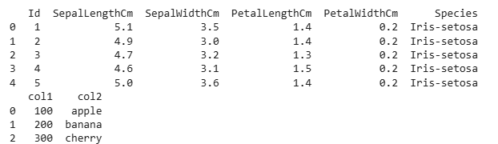
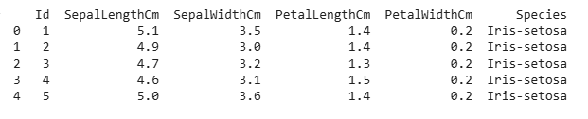
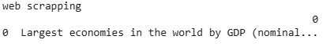
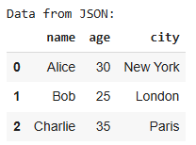
DataFrame successfully exported to exported_data.xlsx

RESULT:
Thus the program was written and executed successfully.

3.EDA-Data Cleaning

AIM:
• Handling missing values: detection, filling, and dropping
• Removing duplicates and unnecessary data
• Data type conversion and ensuring consistency
• Normalize data (e.g., standardization, min-max scaling).

PROGRAM:
import pandas as pd

df = pd.read_csv('/content/Iris.csv') # Replace with your filename
df.head()

# Count missing values in each column
print(df.isnull().sum())

# Drop rows with any missing values
df = df.dropna()

# Drop columns with all missing values
df = df.dropna(axis=1, how='all')

# Check for duplicates
print(df.duplicated().sum())

# Remove duplicates
df = df.drop_duplicates()

# Check datatypes
print(df.dtypes)

from sklearn.preprocessing import MinMaxScaler

scaler = MinMaxScaler()
df[['SepalLengthCm', 'SepalWidthCm', 'PetalLengthCm', 'PetalWidthCm']] = scaler.fit_transform(df[['SepalLengthCm', 'SepalWidthCm', 'PetalLengthCm', 'PetalWidthCm']])
from sklearn.preprocessing import StandardScaler

scaler = StandardScaler()
df[['SepalLengthCm', 'SepalWidthCm', 'PetalLengthCm', 'PetalWidthCm']] = scaler.fit_transform(df[['SepalLengthCm', 'SepalWidthCm', 'PetalLengthCm', 'PetalWidthCm']])
from google.colab import files

df.to_csv('cleaned_data.csv', index=False)
files.download('cleaned_data.csv')

OUTPUT:
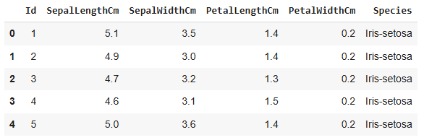
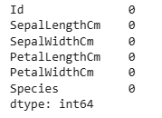
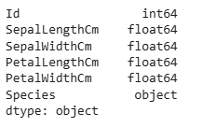

RESULT:
Thus the program was written and executed successfully.

4.EDA-Data Inspection and Analysis

AIM:
- Viewing and inspecting DataFrames
- Filtering and subsetting data using conditions
- Descriptive statistics: measures of central tendency (mean, median, mode) and measures of dispersion (range, variance, standard deviation)

PROGRAM:
import pandas as pd
import seaborn as sns

# Load iris dataset from seaborn
df = sns.load_dataset('iris')

# Step 1: View the first few rows
print("First 5 rows:")
print(df.head())

# Step 2: Inspect DataFrame info
print("\nDataFrame info:")
print(df.info())

# Step 3: Summary statistics
print("\nSummary statistics:")
print(df.describe())

# Step 4: Filtering examples
# Filter flowers with sepal_length > 5.5
filtered_sepal_length = df[df['sepal_length'] > 5.5]
print("\nFlowers with sepal_length > 5.5:")
print(filtered_sepal_length)

# Subset flowers of species 'setosa'
setosa_flowers = df[df['species'] == 'setosa']
print("\nSetosa species flowers:")
print(setosa_flowers)

# Step 5: Descriptive statistics on sepal_length
print("\nDescriptive statistics for sepal_length:")
print("Mean:", df['sepal_length'].mean())SN
print("Median:", df['sepal_length'].median())
print("Mode:", df['sepal_length'].mode()[0])
print("Range:", df['sepal_length'].max() - df['sepal_length'].min())
print("Variance:", df['sepal_length'].var())
print("Standard Deviation:", df['sepal_length'].std())

OUTPUT:
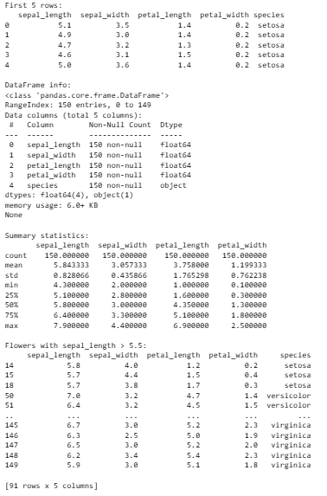
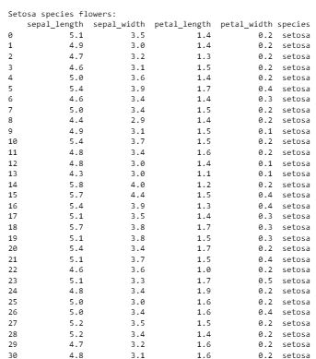
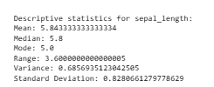

RESULT:
Thus, the given program was written and executed successfully.

5.EDA-Data Visualization

AIM:
To explore and understand the underlying patterns, distributions, and relationships within the dataset through visual representations, which aids in uncovering insights, detecting anomalies, and guiding further analysis.

PROGRAM:
import seaborn as sns
import matplotlib.pyplot as plt

# Load iris dataset
df = sns.load_dataset('iris')

# 1. Histogram and KDE plot of sepal_length
plt.figure(figsize=(8, 4))
sns.histplot(df['sepal_length'], kde=True, bins=20, color='skyblue')
plt.title('Distribution of Sepal Length')
plt.xlabel('Sepal Length (cm)')
plt.ylabel('Frequency')
plt.show()

# 2. Boxplot of sepal_width by species (to see spread and outliers)
plt.figure(figsize=(8, 4))
sns.boxplot(x='species', y='sepal_width', data=df, palette='Set2')
plt.title('Sepal Width by Species')
plt.show()

# 3. Scatter plot of sepal_length vs sepal_width colored by species
plt.figure(figsize=(8, 6))
sns.scatterplot(x='sepal_length', y='sepal_width', hue='species', data=df, palette='deep')
plt.title('Sepal Length vs Sepal Width by Species')
plt.show()

# 4. Pairplot of all numerical features colored by species
sns.pairplot(df, hue='species', palette='bright')
plt.suptitle('Pairplot of Iris Dataset', y=1.02)
plt.show()

# 5. Correlation heatmap of numeric variables
plt.figure(figsize=(6, 5))
sns.heatmap(df.corr(), annot=True, cmap='coolwarm', fmt=".2f")
plt.title('Correlation Heatmap')
plt.show()

OUTPUT:
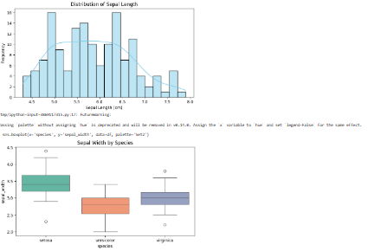
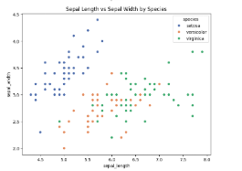
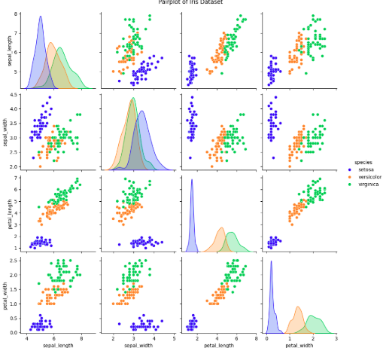
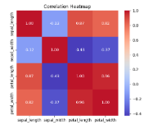

RESULT:
Thus, the given program was written and executed successfully.

